24th October 2018

**YOKOHAMA Celebrates after FIA Master Hill Climb**

YOKOHAMA Italia was all smiles after a prestigious victory alongside the uphill champion Roberto Ragazzi at the exciting FIA Master Hill climb race in Gubbio-Italy, held last weekend.

The excellent result took place on the winding Umbrian roads with Ragazzi winning the GT Cup class after finishing in 6th place in the Open GT category.

Thanks to an impressive all year around performance, the Venetian driver also won the GT Cup in the CIVM (Italian Hill Climb Championship) 2018 after successfully competing in ten spectacular races on the most challenging and zig-zagging climbing roads in Italy. Roberto Ragazzi has always used YOKOHAMA tyres fitting the ADVAN slick A005 on his Ferrari 458 Challenge, which have enabled him to have a firm grip and record times in his racing competitions.

The 10 races that took place so far and which have crowned him with the title in the Italian Mountain Speed Championship have been:

- Coast of Asiago (Vi)

- Nevegal (BL)

- Verzegnis (Ud)

- Fasano (Br)

- Ascoli

- Bondone (Tn)

- Sarnano (Mc)

- Val Camonica (Bs)

- Gubbio (Pg)

- Pedavena (BL)

With the last race still to be held Ragazzi, has already claimed the national title in his category.

A happy Giuseppe Pezzaioli, Head of Motorsport at YOKOHAMA Italia, expressed his satisfaction with the superb performance of Ragazzi and congratulated him on the achievement. “I am very satisfied with this result" and once again our slick tyres have proved their great grip and the very high performance in all the races. Ragazzi is a great driver and we are proud to accompany him on his sporting adventure." concluded Mr Pezzaioli.

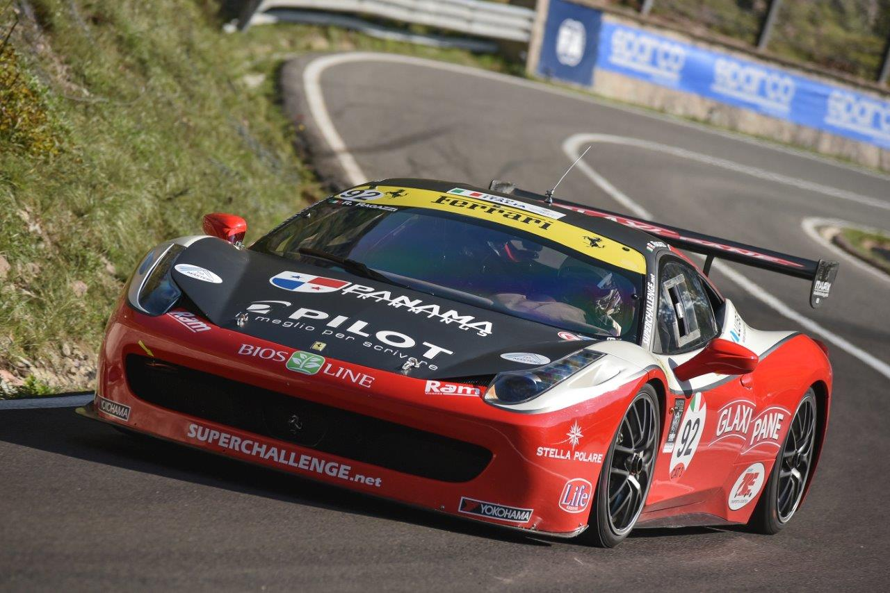

*FIA Master Hill climb race_1*

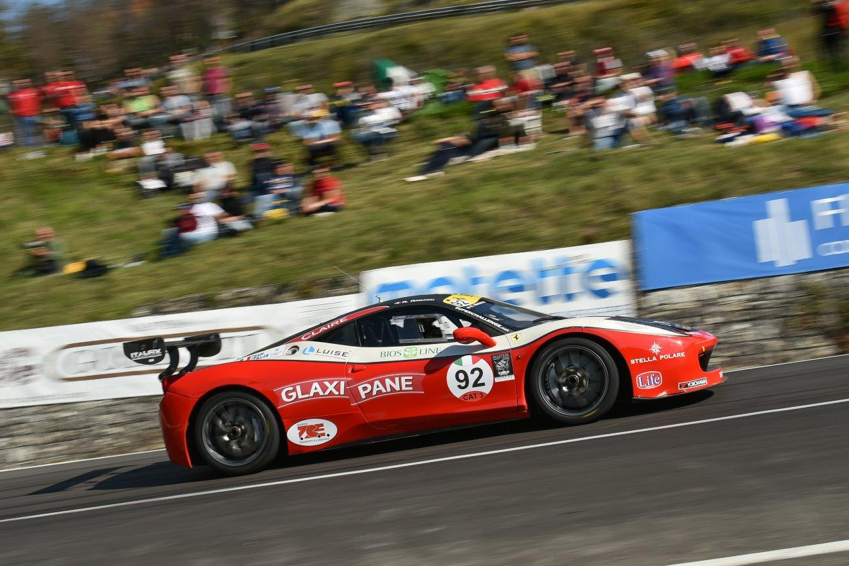

*FIA Master Hill climb race_2*

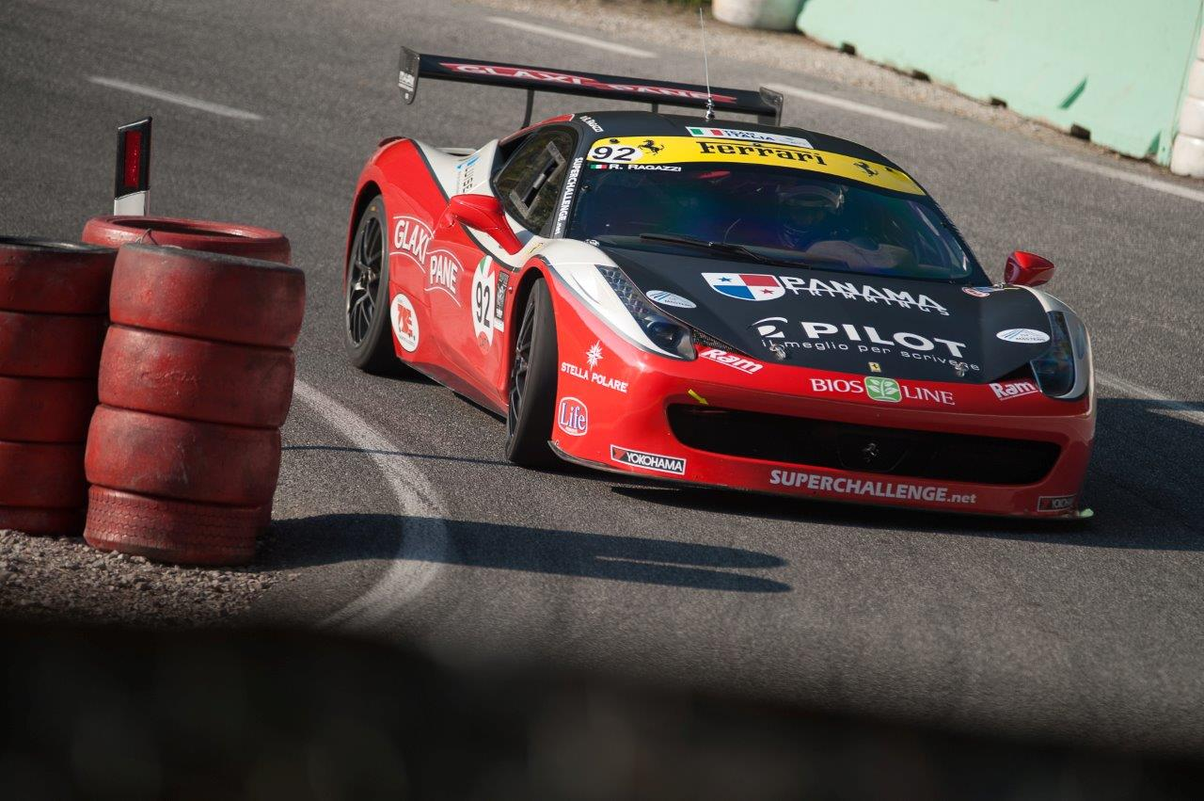

*FIA Master Hill climb race_3*